ç
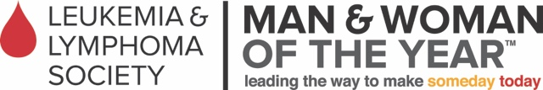

I Am A Hero for Hazel…
Will You Join Me?

Hello friend!

I have been nominated to do something life changing, and I’m excited to share the news with YOU!

Each year the Leukemia & Lymphoma Society (LLS) launches its Man & Woman of the Year (MWOY) fundraising campaign. MWOY is a nationwide campaign that raises vital funds to find cures for blood cancers and to support patients and their families. I was humbled to have been nominated by my good friend, (and now Campaign Manager – every candidate needs a rock star in her corner!!) Rachel Peniche, the current LLS Board Chair for the San Diego/Hawaii Chapter. I agreed to accept the nomination provided I could dedicate my entire campaign to my little friend Hazel Altbaum and her family.

Check out this Super Girl!

Her name is Hazel, and when she was a typical 9-month old, learning to crawl and explore, the doctors took some blood during a well-baby check-up. Within hours of getting the results back, Hazel and her family were admitted to Rady Children’s Hospital in San Diego. The next day, Hazel had her first bone marrow test and sadly it showed she had leukemia.

Ten days later, Tim & Lynn Altbaum received the news no parents ever want to hear, “Hazel has Acute Myeloid Leukemia (AML), a rare form of blood cancer that only 500 children get each year.”

Now at 2.5 years old, Hazel has spent over 169 days in the hospital, had over 14 rounds of chemo and 8 days of radiation, and receives weekly infusions of red blood and/or platelets. She also had an unsuccessful bone marrow transplant.
Sadly, Hazel spent her first birthday in the hospital, and during a recent stay over the holidays, spent most of her time in isolation in her room. Imagine trying to keep a toddler entertained in a hospital room without the freedom to even walk down the hall for fear of infection? No child should have to endure this disease and the limitations it puts on a “normal” childhood.

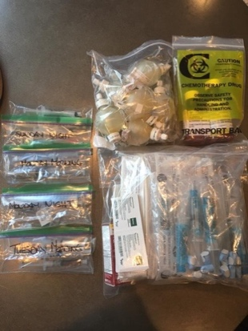
The family recently had the opportunity to visit Disneyland and just to be
gone from home for 2 days, Tim and Lynn had to coordinate all of Hazel’s medicine and out-patient chemo treatment. Imagine taking your kids to the Happiest Place on Earth but yet you have to pack the reality of chemo drugs, syringes and life-saving medications…

When friends are going through such a traumatic event, it’s easy to feel helpless. Thanks to LLS’ Man & Woman of the Year Campaign, there is something we can all do! LLS funded researchers are so close to finding a cure for cancer and that is why I’m running for Woman of the Year. The 10-week fundraising race runs April 7 – June 17, 2017. My goal is to raise over $50,000 because when I do, an AML Research Portfolio can be named after Hazel.

This is where you come in…

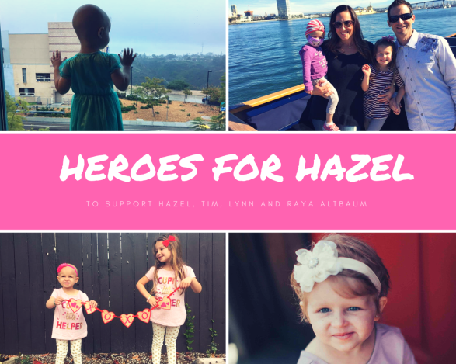
Join us in fighting cancer and finding cures. Together we can beat AML and name a Research Portfolio after Hazel Altbaum. Think of all the kids that will benefit!

We need as many Heroes for Hazel as possible to make this dream a reality. Please make a donation by returning a check to me made payable to LLS or online at my website:

http://www.mwoy.org/pages/sd/sd17/nmatthews

Your tax-deductible contribution will make a difference and will help LLS get even closer to curing AML, so no other kids or adults for that matter will have to go through what Hazel and her family have endured.

The campaign ends on June 17th with a Grand Finale Gala, and I would be honored if you purchased a ticket and attended with me and my family. This is another great way to support the efforts of LLS! We have an amazing chapter in San Diego, and I know you will be impressed with the local impact LLS is making. In 2016, LLS proudly funded close to $10 million in San Diego based cancer research.

Will you be a Hero for Hazel?

Thank you in advance for your consideration and your support!

Sincerely,
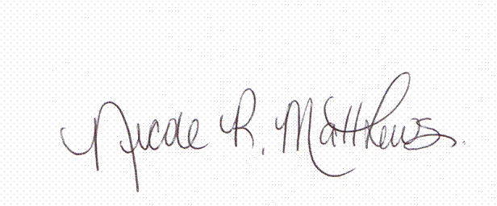

Nicole Matthews
10598 Oakbend Drive – San Diego, CA 92131 | 619-757-6551 | nicole@thehenleycompany.com

P.S. There are many opportunities where you can get more involved with this wonderful campaign. Collectively, we can all make a huge difference! Does your company offer a matching program for giving? Would you like to sponsor the Gala? I’m open to any and all fundraising suggestions so we can exceed our goal. Hazel, and the 4100 other kiddos that are diagnosed with cancer each year, is counting on us!

